|  |
| --- |
| Specification Document |
| 6x6x4 Tic-Tac-Toe Computer Game |

|  |
| --- |
| TEAM DITZY  Daniel Owen  Imran Khan  Taylor Rowan  Zach Meier  Yiming Zhu  Dr. Shengli Yuan  CS 3420  Spring 2016 |

Table of Contents:

Modification History 3

Major Milestones 4

Abstract 5

Document References 6

Glossary 7

Class Diagram 8

Use Case Sequence Diagram 9

Use case 1 9

Use case 2 13

Use case 3 15

Use case 4 17

Use case 5 19

Use case 6 21

Use case 6 23

User Interface 25

# Modification History

* **DITZY Game version 0.1.0 (02-20-2016):**
  + Sample GUI done
* **Requirements document (02-24-2016):**
  + Added view history
* **Specifications document (02-24-2016):**
  + Added exceptional use case scenarios
* **SPMP document (02-24-2016):**
  + Explained configuration control
* **DITZY Game version 0.1.1 (03-29-2016):**
  + Edit GUI to reflect finite state diagram
* **DITZY Game version 0.2.0 (02-20-2016):**
  + Coding event to forms in progress
  + Coding for AI logic in progress

# Major Milestones

|  |  |
| --- | --- |
| **Date** | **Milestones** |
| 01/27/2016 | Basic design and theme decision making |
| 02/20/2016 | Completed preliminary requirements, specifications, and SPMP |
| 02/23/2016 | Presented prelim requirements, specifications, and SPMP to client and received feedback |
| 02/28/2016 | Submitted prelim requirements, specifications, and SPMP to client |
| 03/18/2016 | Updated prelim requirements to define scenarios for every use case. Updated SPMP to explain configuration control. |
| 03/28/2016 | Completed preliminary design and testing |
| 03/31/2016 | Presented prelim design and testing to client and received feedback |
| 04/03/2016 | Submitted prelim design, testing, and prototype along with completed requirements, specifications, and SPMP to client |

# Abstract

The design of a six by six Tic-Tac-Toe (TTT) game application using C#. The use of C# for the game development provides ease of use concerning graphic utilities, increased performance, and legibility. The concern of the project is to develop three main modules or classes for creating the application. These classes perform an interface between player and artificial intelligence (AI) using a graphical user interface (GUI), creating the AI that a player can choose based on difficulty, and the interface between AI and GUI. The GUI includes, amongst all the features, the board for selecting squares. Player who accumulates the most 4-in-a-row sets, formed horizontally, vertically, or diagonally, wins the game. The AI is based on min and max statistical data to determine selection of moves to win. The interface between the AI and GUI displays moves made by the player and AI. In order to display the winning percentage of players, each new player must register with his or her name.

# Document References

|  |  |
| --- | --- |
| **Document** | **Location** |
| Minutes and Time log | Google Drive and GitHub (as backup) |
| Specifications | Google Drive and GitHub (as backup) |
| Requirements | Google Drive and GitHub (as backup) |
| Software Management Plan | Google Drive and GitHub (as backup) |
| Design | Google Drive and GitHub (as backup) |
| Testing | Google Drive and GitHub (as backup) |
| Source code | GitHub |

# Glossary

**Terms:**

|  |  |
| --- | --- |
| **Term** | **Definition** |
| Artificial Intelligence | A simulated version of human thought processes for calculating results without the aid of human intervention. |
| Graphical User Interface | A visual display of objects or abstractions for a user to interact without knowing all the details to run it. |
| Interface | A bridge between to objects to share information. |
| MiniMax | A decision tree to determine the best move based on the player’s choice and, by prediction, the player’s next move. |
| Alpha-Beta pruning | Search algorithm which decreases the number of nodes evaluated by MiniMax Algorithm |

**Acronyms:**

|  |  |
| --- | --- |
| **Acronym** | **Meaning** |
| DITZY | Product Name |
| GUI | Graphical User Interface |
| AI | Artificial Intelligence |
| TTT | Tic Tac Toe |
| 6x6x4 | Board game |

# Class Diagram

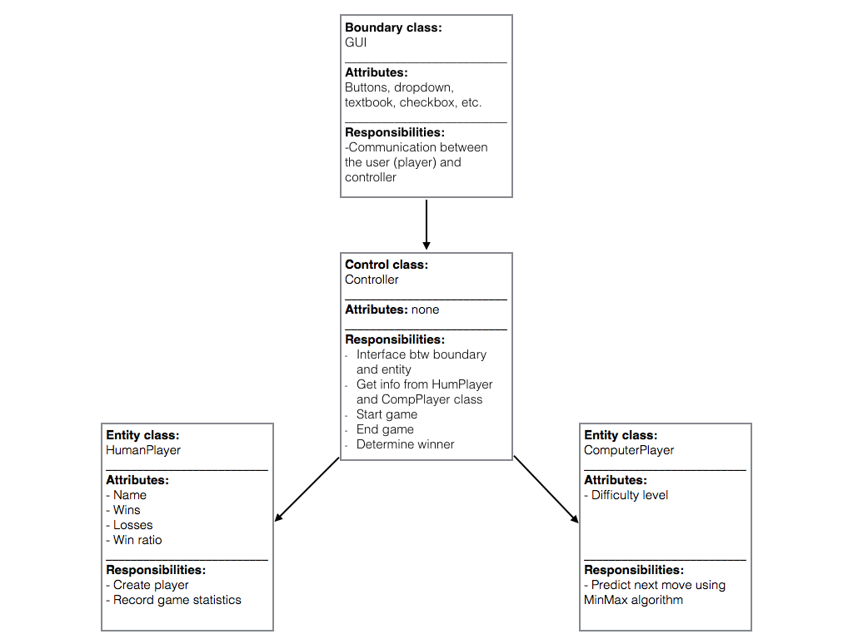

# Use Case & Sequence Diagram

**Use Case 1:**

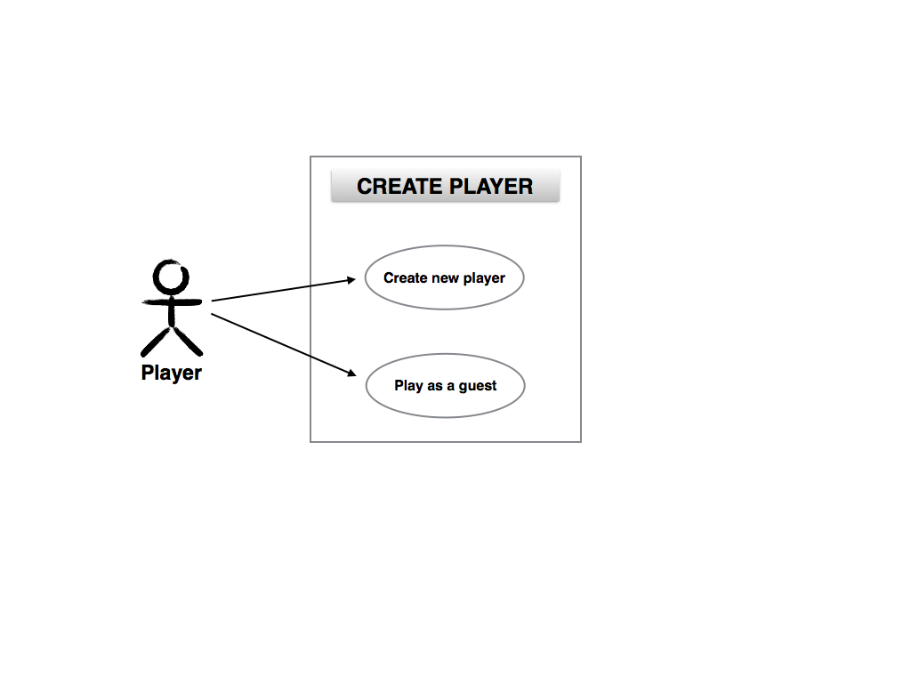

**Figure1a.** Use Case Diagram for Create Player

|  |
| --- |
| Use case 1: Create player (normal) |
| Brief description: Enables a new player to register with player name |
| Step-by-step description:   1. Player enters name and registers player 2. Player will be able to view history of win-loss record |

|  |
| --- |
| Use case 1: Player already registered (exception 1) |
| Brief description: Player name already exist in database |
| Step-by-step description:   1. Player attempts to create player 2. Player will receive message indicating player name already registered |

|  |
| --- |
| Use case 1: Play as a guest (exception 2) |
| Brief description: Enables a new player to play as a guest |
| Step-by-step description:   1. Player do not create player and plays as a guest 2. Player will not be able to view history of win-loss record |



**Figure 1b.** Sequence Diagram for Create Player (Normal)



**Figure 1c.** Sequence Diagram for Create Player (Exception 1)



**Figure 1d.** Sequence Diagram for Create Player (Exception 2)

**Use Case 2:**

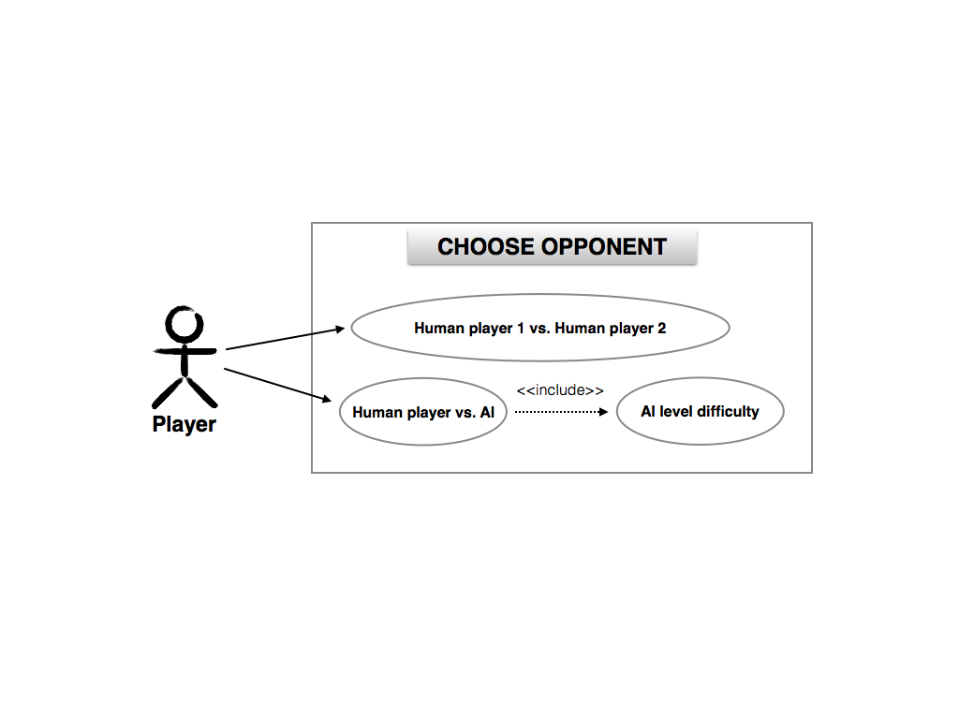

**Figure2a.** Use Case Diagram for Opponent Selection

|  |
| --- |
| Use case 2: Choose opponent (normal) |
| Brief description: Enables player to choose between human vs. human |
| Step-by-step description:   1. Player selects human vs. human 2. Player 1 will have already chosen to play either as a registered player or guest 3. Player 2 will select from a dropdown menu a registered player name or play as a guest |

|  |
| --- |
| Use case 2: Choose opponent (exception) |
| Brief description: Player choose to play against the computer or A.I. |
| Step-by-step description:   1. Player selects his or her name from dropdown menu or play as a guest 2. Player selects human vs. computer |



**Figure 2b.** Sequence Diagram for Opponent Selection (Normal)



**Figure 2c.** Sequence Diagram for Opponent Selection (Exception)

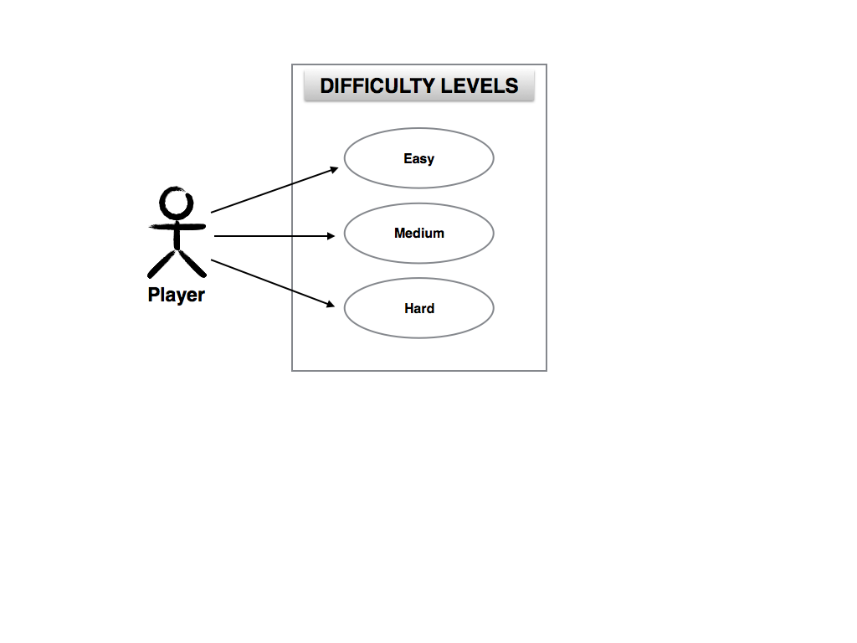

**Use Case 3:**

**Figure3a.** Use Case Diagram for AI Difficulty

|  |
| --- |
| Use case 3: Choose difficulty levels (normal) |
| Brief description: Enables player to choose difficulty levels |
| Step-by-step description:   1. If player selects player vs. computer, player chooses difficulty levels 2. Player can choose easy, medium, or hard. Medium is default |

|  |
| --- |
| Use case 3: Choose difficulty levels (exception) |
| Brief description: Difficulty level not available if player vs. player is selected |
| Step-by-step description:   1. If player selects player vs. player, this option will not be displayed. |



**Figure 3b.** Sequence Diagram for AI Difficulty (Normal)



**Figure 3c.** Sequence Diagram for AI Difficulty (Exception)

**Use Case 4:**

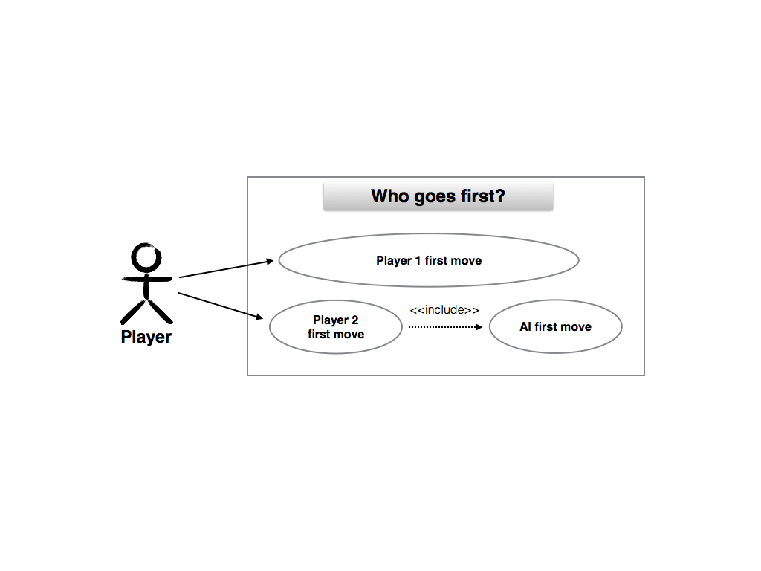

**Figure 4a.** Use Case Diagram for Who Goes First

|  |
| --- |
| Use case 4: Choose who goes first (normal) |
| Brief description: Player chooses who makes the first move |
| Step-by-step description:   1. Player selects player 1 (self) to make the first move 2. Or player selects player 2 (or A.I.) to make the first move |

|  |
| --- |
| Use case 4: Choose who goes first (exception) |
| None |



**Figure 4b.** Sequence Diagram for Who Goes First

**Use Case 5:**

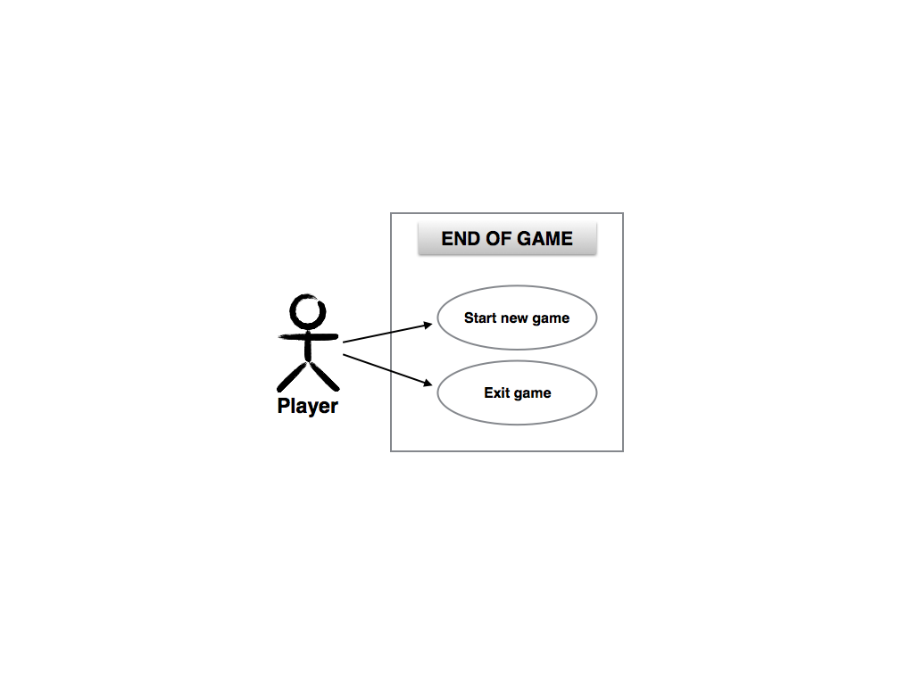

**Figure 5a.** Use Case Diagram for End of Game

|  |
| --- |
| Use case 5: Options at end of game (normal) |
| Brief description: Player chooses to start new game |
| Step-by-step description:   1. Player adjust selection of difficulty (if playing against A.I.) and who goes first 2. Player select start new game |

|  |
| --- |
| Use case 5: Options at end of game (exception) |
| Brief description: Player chooses to log out of game |
| Step-by-step description:   1. Player select log out |



**Figure 5b.** Sequence Diagram for End of Game (Normal)



**Figure 5c.** Sequence Diagram for End of Game (Exception)

**Use Case 6:**

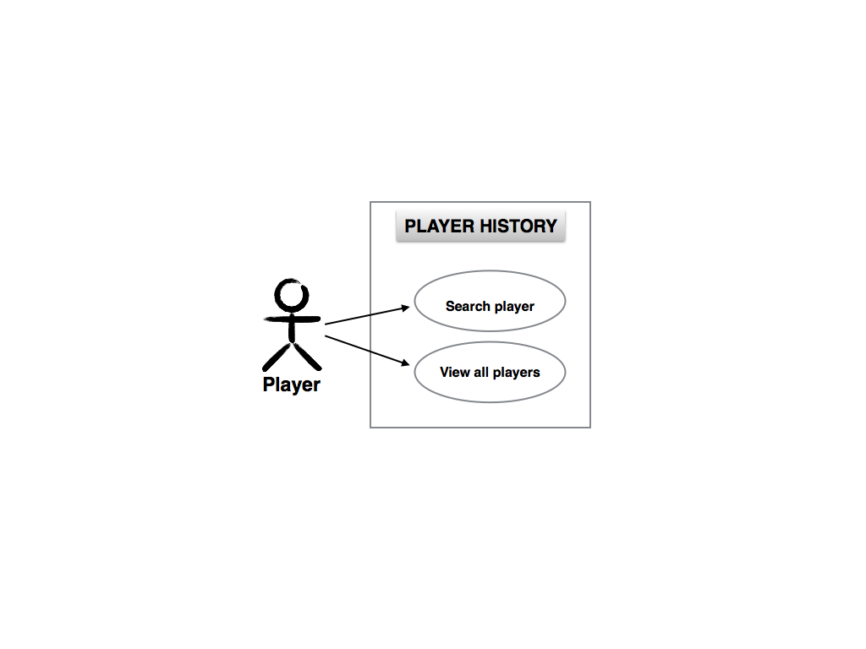

**Figure 6a.** Use Case Diagram for Player History

|  |
| --- |
| Use case 5: Player history (normal) |
| Brief description: Player chooses to view player history |
| Step-by-step description:   1. Player select player history 2. Player can select specific player or view all player options to see win, loss, draw, and win ratio |

|  |
| --- |
| Use case 5: Player history (exception) |
| None |



**Figure 6b.** Sequence Diagram for Player History

**Use Case 7:**

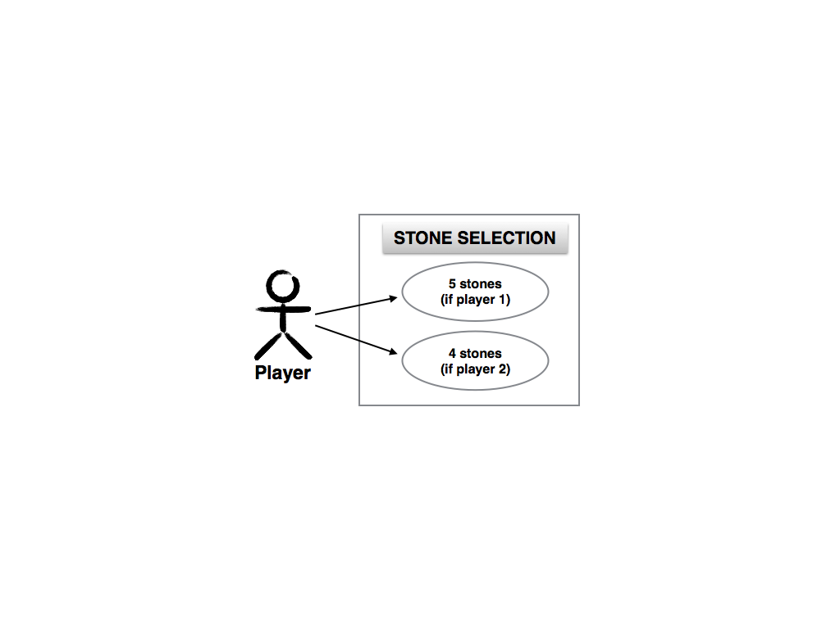

**Figure 7a.** Use Case Diagram for Stone Selection

|  |
| --- |
| Use case 7: Choose stone (normal) |
| Brief description: Player chooses stone |
| Step-by-step description:   1. Five stones are displayed for selection before start of game 2. Players select type of stone to place on board when playing against AI |

|  |
| --- |
| Use case 7: Choose stone (exception) |
| Brief description: Player 2 tries to choose the same stone as player 1 |
| Step-by-step description:   1. After player 1 selects one of five stones, the chosen stone is removed from player 2’s list of stones 2. Player 2 selects one of fours stones to place on board |

# 

**Figure 7b.** Use Case Diagram for Stone Selection (Normal)



**Figure 7c.** Use Case Diagram for Stone Selection (Exception)

# User Interface

Player transitions between three GUIs:

1. Player creation, game mode selection, and player history
2. Player history with search and view all features
3. Player(s) selection
4. 6x6 game board with player turn selection, win-loss record, XO designation, and AI difficulty selection (if playing against AI)

GUI #1

A new player enters his or her name and select “Create Player” to create a new player. In “Game Mode,” player selects between “Player vs. Player” or “Player vs. Computer.” The 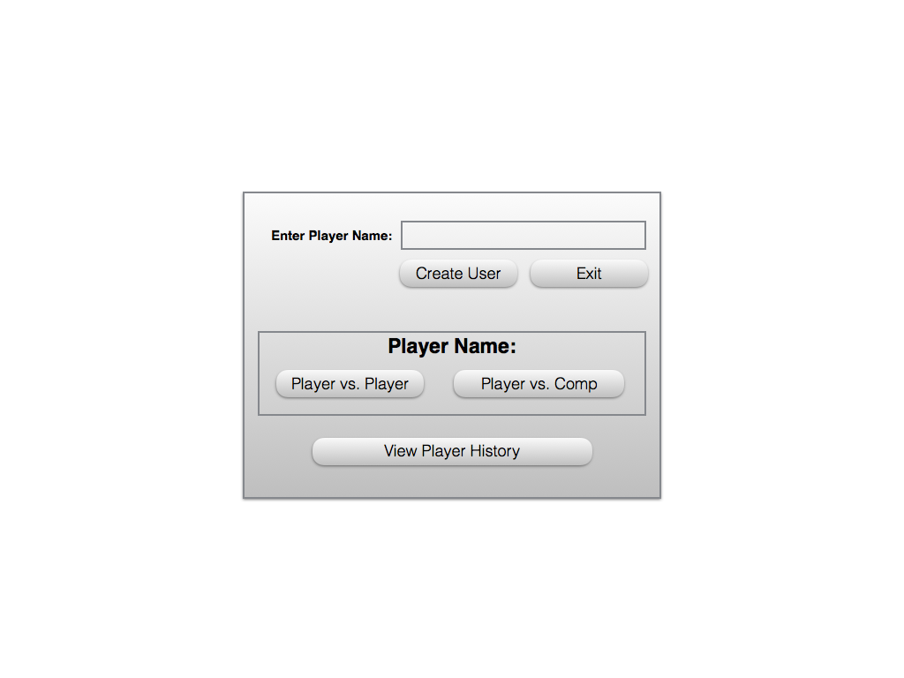player can choose to not play at all and view existing players’ win-loss record.

**Figure 7.** GUI #1

GUI #2

In player history, registered or non-registered player can view the win-loss record of all registered players. Features include buttons for “Search” and “View All.”

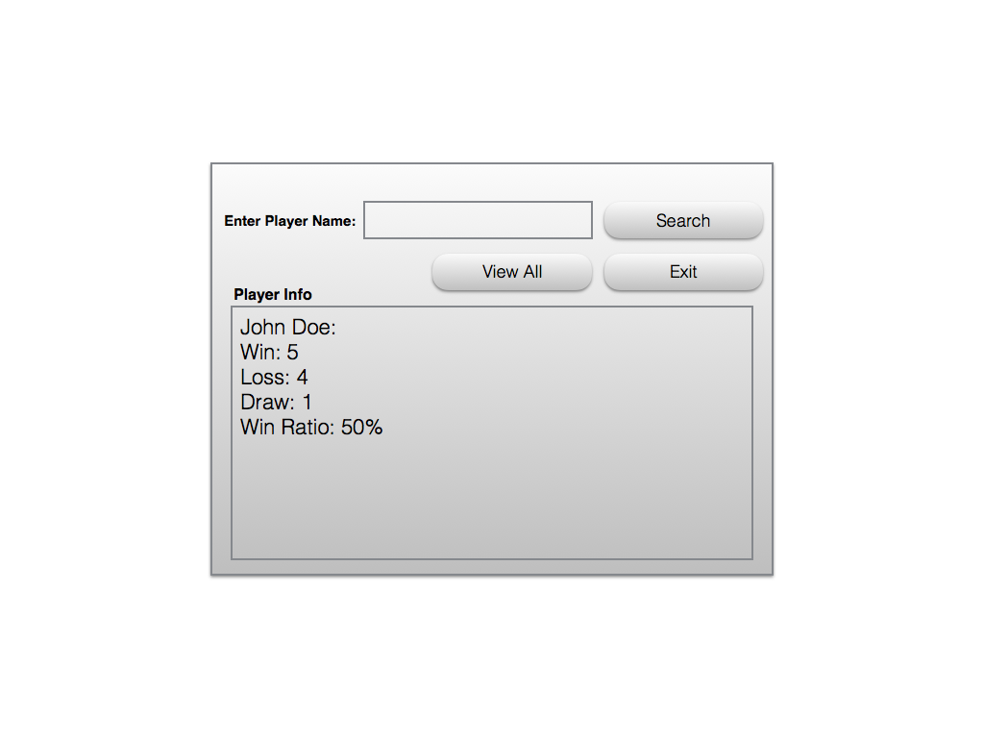**Figure 8.** GUI #2

GUI #3

If “Player vs. Player” in GUI #1 is selected, registered players are selected for player 1 and player 2 from drop-down menu. If “Player vs. Computer” is selected, the registered 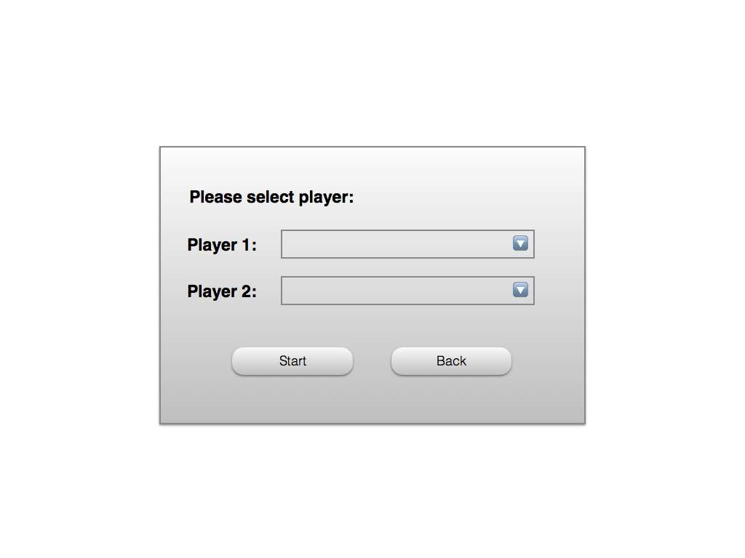player selects his or her name from the drop-down menu.

**Figure 9.** GUI #3

GUI #4

The 6x6 game board is displayed here. Player(s) decide which player to make the first move before starting the game. If “Player vs. Computer” is selected in GUI #1, player selects the difficulty: Easy, Medium, or Hard before starting the game. On the same GUI, player info is displayed to identify which player is “X” or “O.” Lastly, as long as the player(s) does not exit, win-loss record will be displayed for each continuous session.

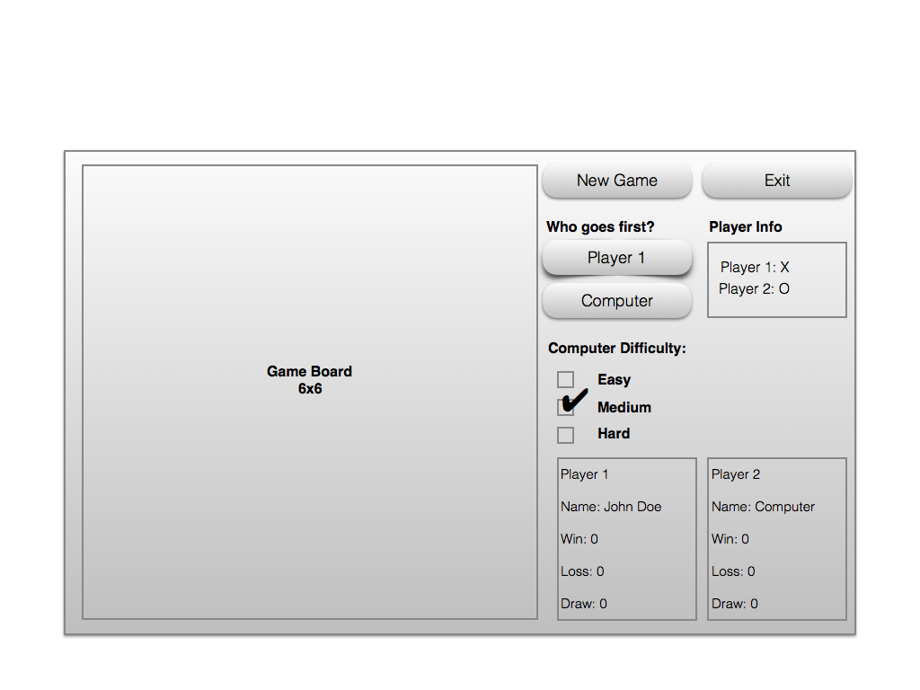

**Figure 10.** GUI #4